# Introduction

This document will help users get started programming the CAN Logger 3.

# Getting started

This section will instruct users on how to properly install all necessary software and dependencies required to get started programming the CAN Logger 3.

1. Install the latest version of the Arduino IDE found at: <https://www.arduino.cc/en/main/software>
2. Install the latest version of Teensyduino found at: <https://www.pjrc.com/teensy/td_download.html>
3. Clone the CAN-Logger-3 GitHub repository found at: <https://github.com/SystemsCyber/CAN-Logger-3>
4. Install the following libraries from the “libraries” directory of the CAN-Logger-3 GitHub repository:

* cryptolibAESSHA
* FlexCAN_Library-master
* MCP_CAN_lib
* OneButton
* SdFs
* sha256
* SparkFun_ATECCX09a_Arduino_Library-master
* WiFi101

1. Delete the default FlexCAN library if it exists. On Windows go to “C:\Program Files (x86)\Arduino\libraries” and delete the FlexCAN_Library folder
2. Connect to the CAN Logger using the mini USB connector
3. Open the Arduino IDE. In the Tools -> Board menu select Teensyduino -> Teensy 3.6 (see Figure *1* below).

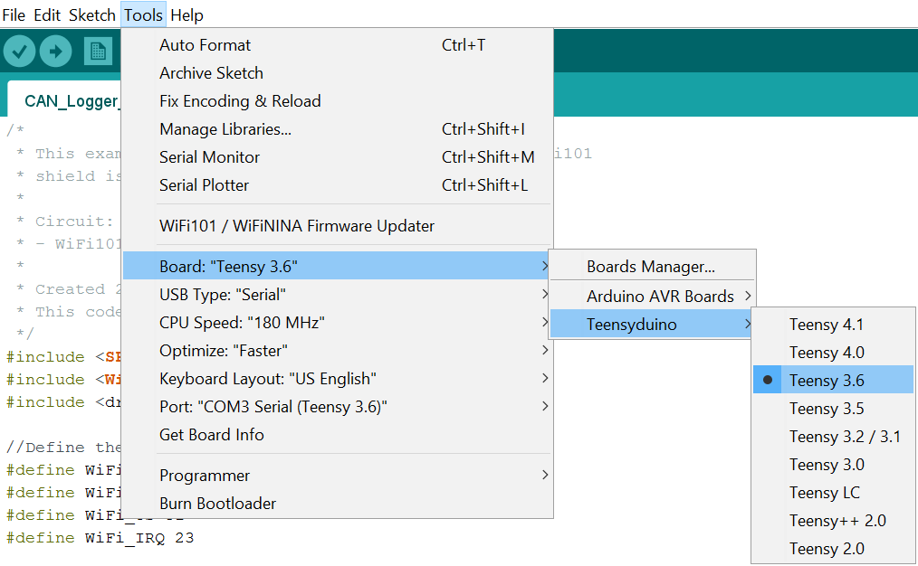

Figure 1. Adding the Teensy 3.6 board.

1. Set the port by going to Tools -> Port and select whichever one contains “Teensy 3.6” (see Figure *2*). Verify that “USB Type” is set to “Serial”.

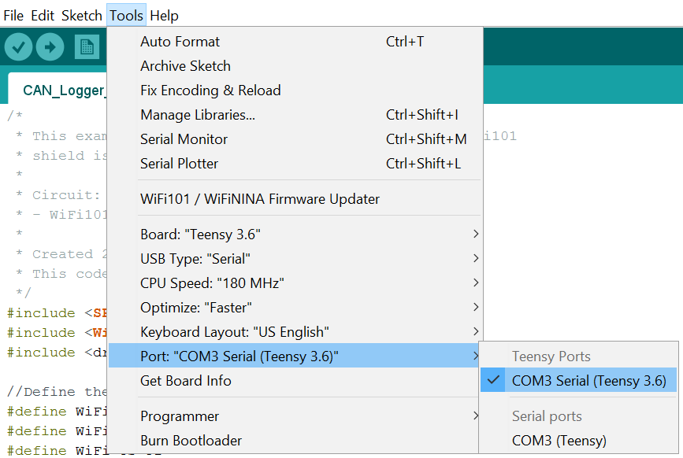

Figure 2. Setting port.

1. If using the WiFi module, make sure that WiFi shield and correct firmware are installed.
   1. Go to your Sketchbook location. If you unsure of your Sketchbook location, open the Arduino IDE go to “File-> Preferences”. On Windows computers the default location is “C:\Users\{user_name}\Documents\Arduino” where {user_name} is your Windows login name.
   2. Navigate to WiFi101\examples\CAN_Logger_Firmware_Check and open CAN_Logger_Firmware_Check.ino
   3. Press the program button on the Teensy board (see Figure *3* below for a photograph indicating where to find the program button) and upload the CAN_Logger_Firmware_Check sketch to the CAN Logger.

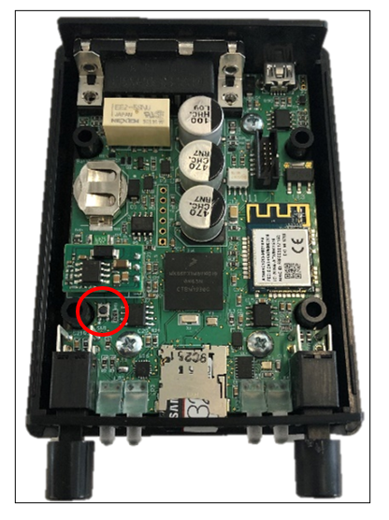

Figure 3. CAN Logger with program button circled.

* 1. Open the Serial Monitor window. If you see the following message you must change the WiFi module to SPI1.

WiFi101 firmware check.

WiFi101 shield: NOT PRESENT

To do this, navigate to your sketchbook and open the file: WiFi101/src/bus_wrapper/source/nm_bus_wrapper_samd21.cpp. Modify line 54 from: #define WINC1501_SPI SPI to: #define WINC1501_SPI SPI1. Re-upload the sketch and try again.

If you see the following message you must update the firmware (see Step 10):

WiFi101 firmware check.

WiFi101 shield: DETECTED

Firmware version installed: 19.4.4

Latest firmware version available : 19.6.1

Check result: NOT PASSED

- The firmware version on the shield do not match the

   version required by the library, you may experience

   issues or failures.

If you see the following message your firmware is up to date and no update is necessary:

WiFi101 firmware check.WiFi101 shield: DETECTEDFirmware version installed: 19.6.1Latest firmware version available : 19.6.1Check result: PASSED

1. If the results of Step 9 indicate that the firmware needs to be updated follow the following steps.
   1. Navigate to your sketchbook, go to WiFi101\examples\CAN_Logger_Firmware_Update, and open CAN_Logger_Firmware_Update.ino.
   2. Press the program button and upload this sketch to the CAN Logger.
   3. Open the Tools dropdown menu and there should be a new option “WiFi101 / WiFiNINA Firmware Updater” (see Figure *4*).

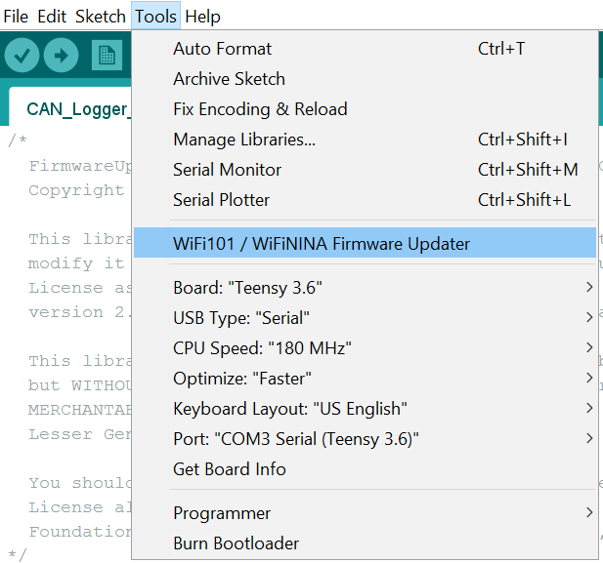

Figure 4. Tools dropdown menu showing new WiFi Firmware Updater option.

* 1. Open the WiFi Firmware updater. You should see the window shown in Figure *5*.

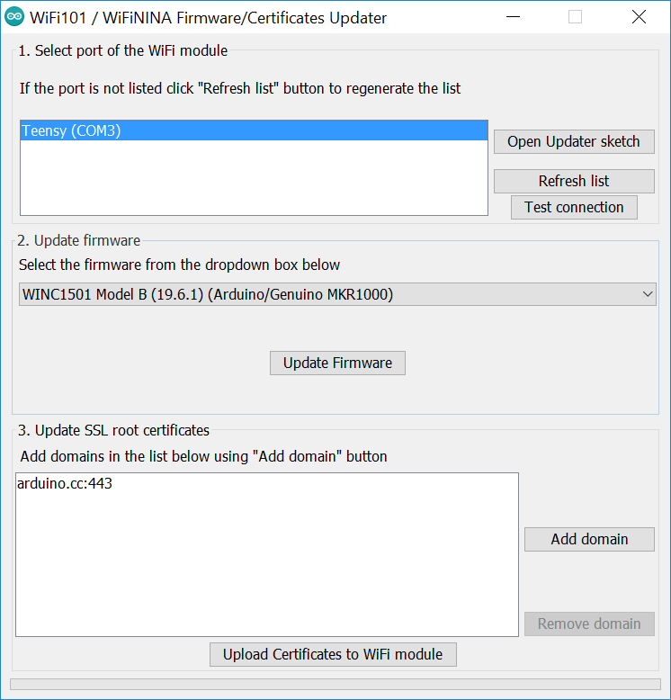

Figure 5. WiFi101 / WiFiNINA Firmware/Certificates Updater.

* 1. Select the Teensy port under “Select port or the WiFi-module” and press “Test connection” to verify that the updater is communicating. You should see the following message:

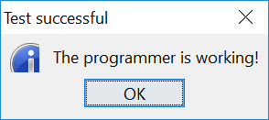

* 1. Select “WINC1501 Model B (19.6.1) (Arduino/Genuino MKR1000)” and press “Update Firmware”. You should see the following message:

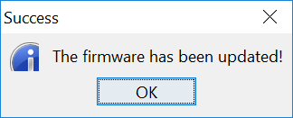

# Using the WiFi module

The ATWINC1510-MR210PB WiFi module communicates with the Kinetis K66 microcontroller using Serial Peripheral Interface (SPI) channel SPI1. In order to open the correct channel, the WiFi101 library must be modified. In your sketchbook, navigate to WiFi101/src/bus_wrapper/source/nm_bus_wrapper_samd21.cpp. Ensure that line 54 reads “#define WINC1501_SPI SPI1”. If you obtained the library from the SystemsCyber/CAN-Logger-3 repository this modification should already be in place. If you see “#define WINC1501_SPI SPI” (without the ‘1’) add the ‘1’ and save the file.

For any program using the WiFi module, the pins that connect the module to the microcontroller must be defined. The following lines of code must appear at the beginning of any code to define the pin assignments:

#define WiFi_EN 24

#define WiFi_RST 25

#define WiFi_CS 31

#define WiFi_IRQ 23

Additionally, the following lines should be included in your setup function to initialize the WiFi module:

WiFi.setPins(WiFi_CS,WiFi_IRQ,WiFi_RST);

pinMode(WiFi_EN, OUTPUT);

digitalWrite(WiFi_EN,HIGH);